Rushabh Patel
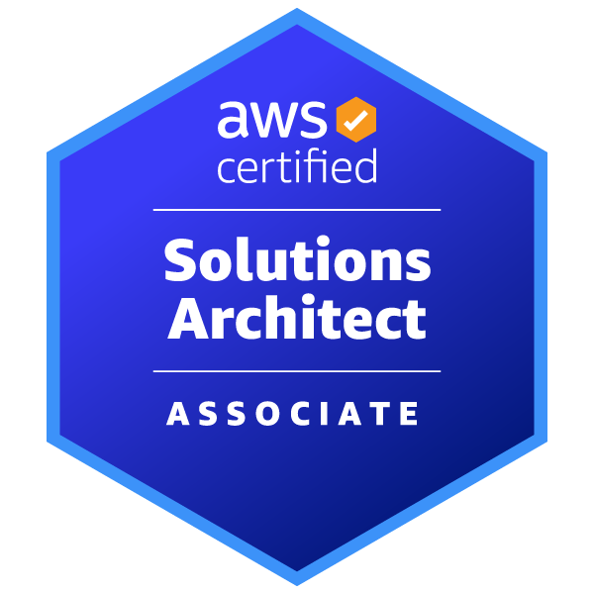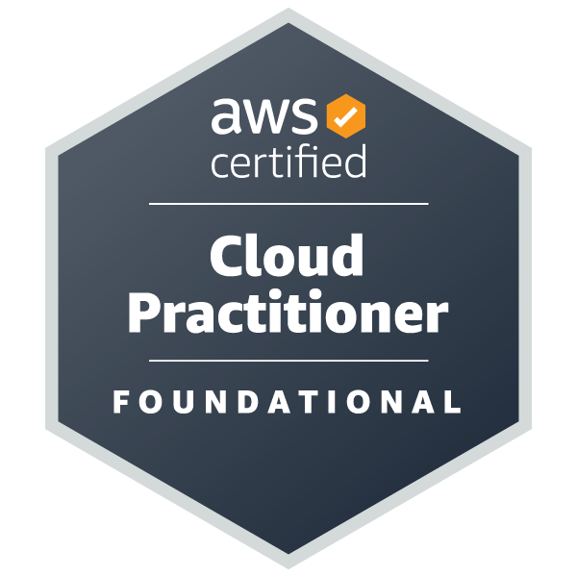
DevOps Engineer | Site Reliability Engineer | Cloud Engineer
E: patel.rushabh0125@gmail.com | P: +1 3658055461 | L: www.linkedin.com/in/rushabh19/ | L: Toronto, CA

Professional Summary
- With over 3+ years as a DevOps Engineer, proficient in designing, deploying, and managing applications on AWS, ensuring highly available, and fault-tolerant systems
- Expertise in containerization and orchestration using Docker and Kubernetes, enhancing application portability and scaling across multiple environments
- Hands-on experience in key AWS services, including EC2, S3, Lambda, RDS, VPC, and others, with a focus on cost optimization and robust security implementation
- Proficient in CI/CD using Jenkins, Github Actions, Azure DevOps, Terraform, and AWS CloudFormation, enabling the automation of build, test, and deployment pipelines for enhanced efficiency and scalability
- Versatile in leveraging AWS Lambda for serverless architectures and managing containers using ECS, EKS, and Fargate, utilizing IAM, VPC, VPN, Security Hub, and GuardDuty to enhance scalability and ensure security
- Extensive experience in using monitoring tools like CloudWatch, Azure Monitor, Grafana, Prometheus, Nagios, ELK, Dynatrace, and Datadog to identify and mitigate system performance issues proactively
- Expert in scripting with Python and Bash on Linux systems, facilitating task automation and enhancing operational efficiency
- Experienced in Site Reliability for high-traffic applications, a solid understanding of Service level objectives (SLO), Service Level Indicators (SLI), and SLA, and sound knowledge of the implementation
- Specialized in migrating large-scale applications and databases to the cloud, conducting thorough planning, execution, and post-migration optimization to enhance operational efficiency and scalability
- Competent in configuring and managing AWS network services such as Amazon VPC, Route 53, Direct Connect, and AWS Transit Gateway, Service Now enhancing network reliability and performance
- Demonstrated proficiency in using AWS CloudWatch, AWS X-Ray, and AWS Cost Explorer to effectively monitor and optimize resource utilization, achieving a substantial reduction in infrastructure costs.
- Expertise in securing cloud environments using encryption AWS KMS, IAM policies, and hybrid architectures, alongside protocols like OAuth and SSL/TLS for secure data transmission.
- Well-versed in Agile methodologies, actively collaborating with cross-functional teams and stakeholders to enhance software development lifecycles through iterative development, continuous feedback, and adaptive planning
Technical Skillset
- Cloud Services: EC2, ECR, Lambda, API Gateway, ECS, VPC, S3, VPN, VPC Peering, Endpoints, CloudWatch, Auto Scaling, IAM, Load Balancers, Auto Scaling, CloudFront
- Infrastructure Automation: Terraform, AWS CloudFormation, Ansible
- Containerization: Kubernetes, Docker
- CICD Tools: Jenkins, Git, GitHub Actions
- Scripting Languages: Python and Bash
- Monitoring Tool: CloudWatch, Grafana, Prometheus, ELK, Dynatrace, Datadog
- Databases: SQL, MySQL, DynamoDB
- Atlassian Tools and Others: Jira, Agile, Confluence, Splunk, IaaS, PaaS, SaaS, SLA, SLO, SLI
Education & Certifications
- Master's In Cloud Computing at Northeastern University Sept 2022 - March 2023
- Bachelors in computer science at R. N. G. Patel Institute of Technology July 2016 - Aug 2020
- HashiCorp Certified: Terraform Associate (003)
- AWS Certified Solutions Architect – Associate
- AWS Certified Cloud Practitioner

Work Experience
DevOps Support Engineer RBC, Vancouver April 2023 – Present
- Designed, implemented, and maintained CI/CD pipelines using Jenkins, GitHub Actions, and Azure DevOps, ensuring secure and compliant software deployments for banking applications, reducing deployment time by 40%.
- Managed and supported containerized applications using Docker and Kubernetes, optimizing scalability and reliability in a highly regulated financial environment, improving load handling by 50%.
- Provided L2/L3 production support for critical banking applications, troubleshooting CI/CD failures, deployment issues, and system outages, reducing downtime by 60%.
- Developed and automated infrastructure monitoring using Prometheus, Grafana, and ELK Stack, enabling real-time tracking and ensuring 99.9% system uptime for mission-critical banking services.
- Administered cloud and on-premises infrastructure using AWS while enforcing strict security policies, SOC 2, PCI-DSS, ISO 27001)—enhancing security and reducing compliance violations by 30%.
- Implemented security best practices by configuring IAM policies, role-based access control (RBAC), encryption standards, and vulnerability scanning, reducing security incidents by 50%.
- Automated deployment processes, log rotation, and system health checks using Python, Bash, and PowerShell scripts, reducing manual intervention by 70% and improving operational efficiency.
- Managed and optimized artifact repositories using JFrog Artifactory, Nexus or secure storage and retrieval of banking application binaries, reducing build failures by 20%.
- Utilized Ansible and Terraform to automate infrastructure provisioning, ensuring consistent and compliant deployments across banking data centers and cloud environments.
- Collaborated with cross-functional teams, including SRE, security, and development teams, to enhance system performance, security, and deployment efficiency, reducing issue resolution time by 35%.
- Maintained detailed documentation, runbooks, and compliance reports, ensuring audit readiness and reducing onboarding time for new team members by 30%.

Software Developer Colourtex Ind Ltd, India Dec 2020 - Aug 2022

- Developed, tested, and debugged SAP modules using ABAP, enhancing system reliability and reducing errors in custom SAP applications.
- Provided end-user training on module pool programs, improving system adoption and reducing support tickets related to system usage by 25%.
- Designed and implemented a report generation program, enabling real-time insights for stakeholders and increasing on-time decision-making by 20%.
- Authored comprehensive BAPI documentation and provided integration support, accelerating integration project timelines by 40% and improving cross-team collaboration.

AWS (EC2, S3, RDS, Lambda, VPC, IAM, EKS, ECS), Google Cloud Platform (GCP), Microsoft Azure, Terraform, Pulumi, AWS CloudFormation, AWS CDK, Ansible, Packer, Jenkins, GitHub Actions, GitLab CI/CD, AWS Code Pipeline, Code Build, Code Deploy, Spinnaker, Argo CD, Flux CD, Docker, Kubernetes (EKS, ECS, K3s), Helm, Kubernetes Operators, Podman, Open Telemetry, AWS CloudWatch, Prometheus, Grafana, Datadog, Honeycomb, Dynatrace, New Relic, Splunk, Sumo Logic, AWS X-Ray, ELK Stack, Jaeger, Thanos, AWS Security Hub, AWS Macie, AWS Guard Duty, HashiCorp Vault, Trivy, Falco, AWS WAF, Security Groups, VPN, AWS Transit Gateway, Istio, Linkerd, Consul, Envoy Proxy, NGINX Ingress Controller, Apache Kafka, RabbitMQ, AWS SQS, AWS SNS, AWS Event Bridge, MySQL, PostgreSQL, MongoDB, DynamoDB, Amazon Redshift, Cassandra, Redis, AWS Cost Explorer, Cloud Health, Trusted Advisor, Kubecost, Spot.io, AWS Budgets, Git, GitHub, GitLab, Bitbucket, Agile, Scrum, JIRA, GitOps, FinOps, Site Reliability Engineering (SRE), Chaos Engineering (Gremlin, Litmus Chaos), Python, Bash, JavaScript.
improvement, activities, CentOS, bitbucket

